TASK 1
You should spend about 20 minutes on this task. Write at least 150 words.
After you finish, use the checklist to evaluate your writing task. Then, compare your task with the sample answer.

The chart below gives information about the production of grains, measured in million metric tons, from the years 2010 to 2015, with projections until 2030.
Summarise the information by selecting and reporting the main features, and make comparisons where relevant.
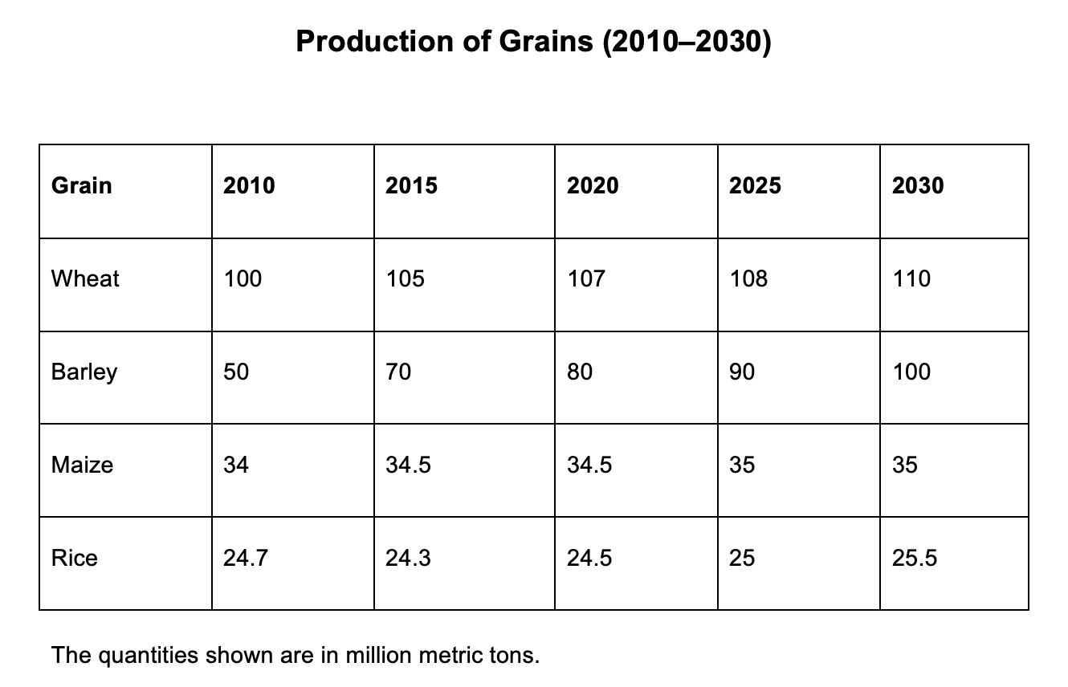

TASK 2
You should spend about 40 minutes on this task. Write at least 250 words.
After you finish, use the checklist to evaluate your writing task. Then, compare your task with the sample answer.

Write about the following topic: Unhealthy eating has a negative effect on both individuals and the society in which they live. Some people think that the government should tax unhealthy foods while others believe that a ‘fat tax’ is unfair and unnecessary.
Discuss both these views and give your own opinion.
Give reasons for your answer and include any relevant examples from your own knowledge or experience.

